Better starts today
Join the VHA as we go smoke free on OCTOBER 1st
VHA cares about your health and is going smoke free per Directive 1085 and 1085.01*.

U.S. Department ofVeterans Affairs
VA
Local Contact Information:
Patient Advocate: 816-861-4700 Ext. 52273 Employee Wellness: Ext. 52965
Employee Health: Ext. 57206 Immediate Supervisor

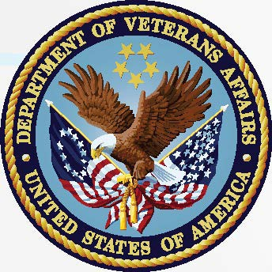

*VHA Directive 1085 implements a smoke-free policy for employees, patients, visitors, contractors, volunteers, and vendors at VA health care facilities.

